18 Years = 6,570 days

This is your window of opportunity! In 18 years it will be time for your child to GO out into the world. The days may feel long, but the years will fly by too fast! As a parent, you have a God-given calling to prepare your child to GO into this world. BUT what should they be going with? As a parent it is your calling to implant the Christian worldview into the heart of your child, and prepare them to GO into this world armed with the Gospel of Jesus Christ!

Preparing your child to GO is not something that happens by accident. It requires intentional training. At Union, we believe there are different phases of parenting, and each phase presents unique challenges and rewards. We believe it is very important to make sure to celebrate the transition out of one phase as well as prepare for the phase that is coming next.

Parenting Phases:
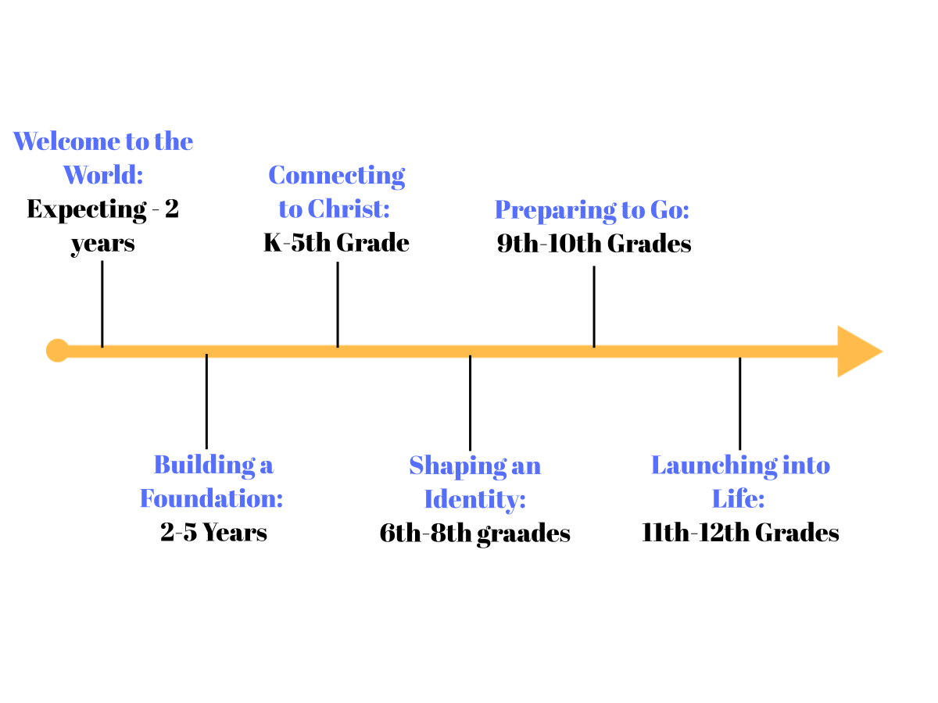
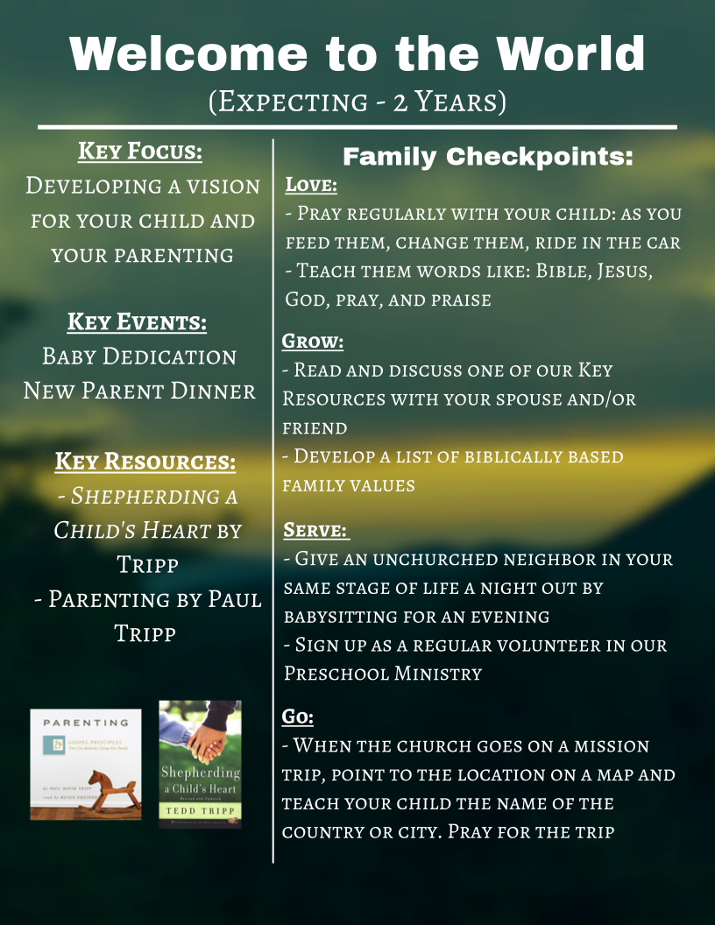
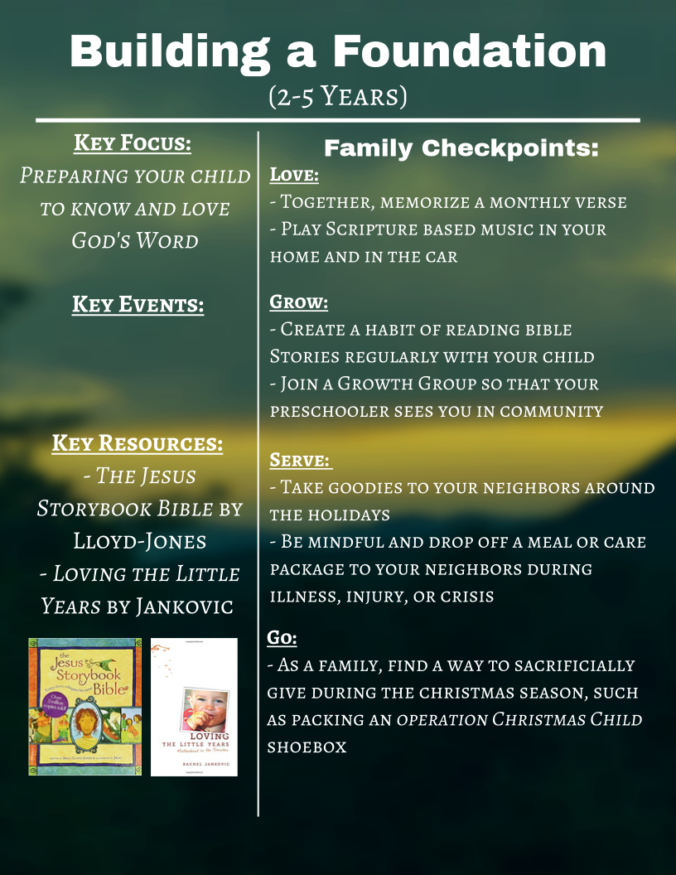
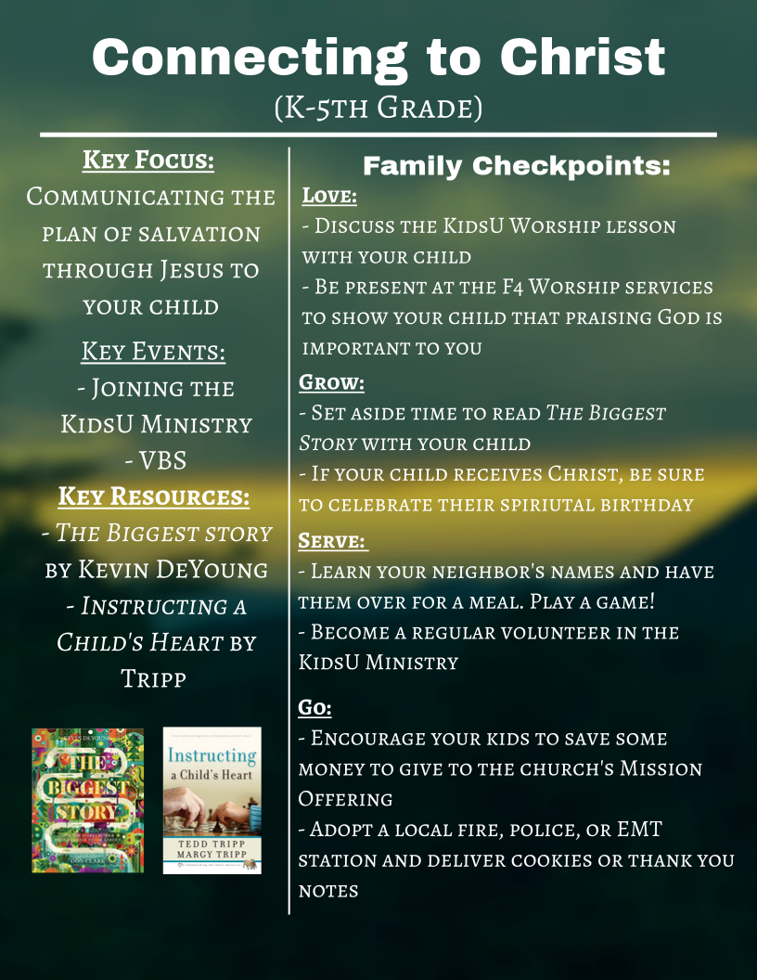
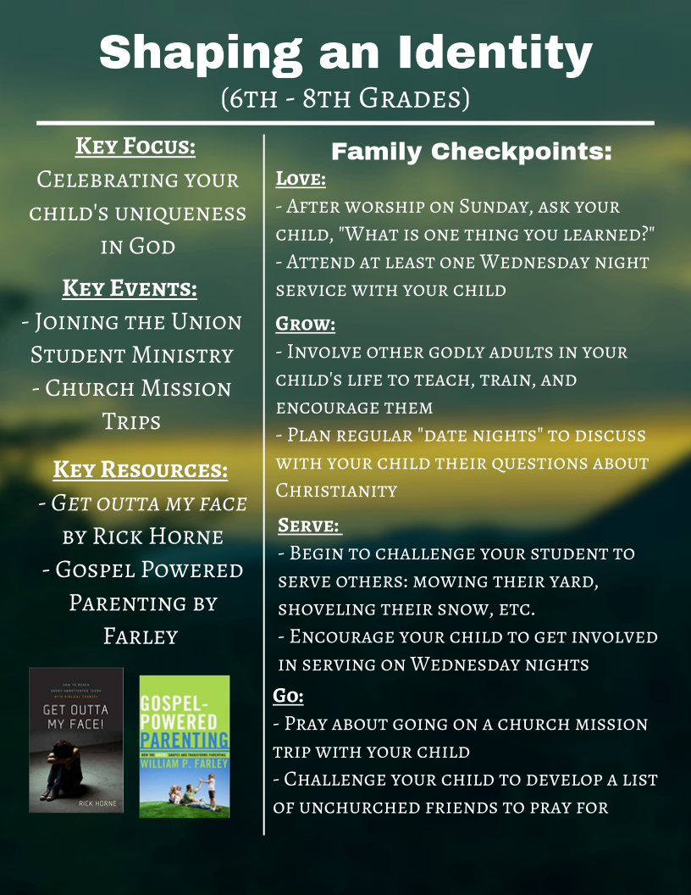
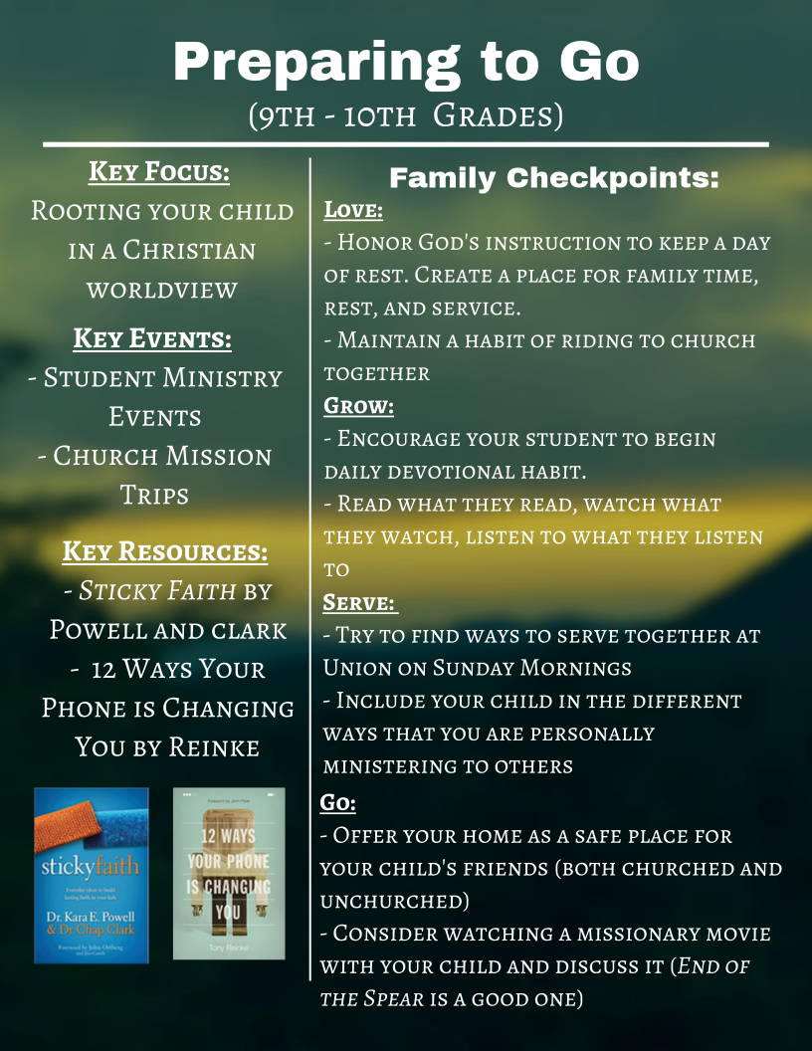
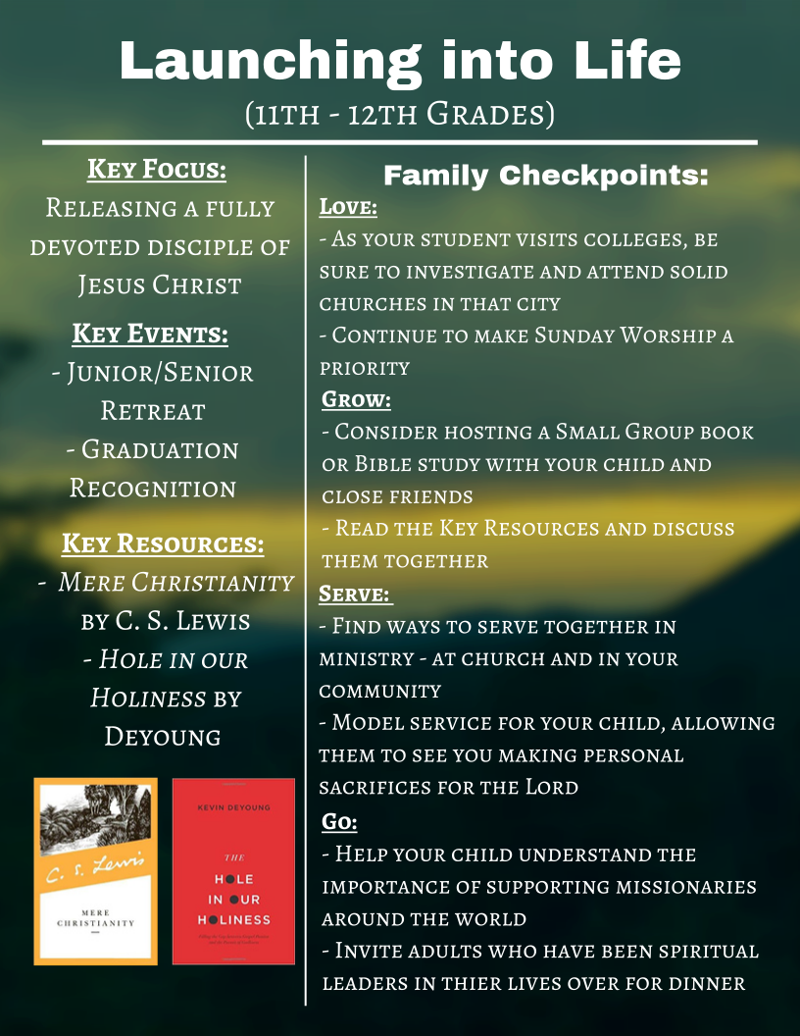
For Additional Reading

Family Worship by Donald Whitney
Disciplines of a Godly Family by Kent and Barbara Hughes
The Faithful Parent by Martha Peace and Stuart Scott
Parenting God’s Way by Alistair Begg
The Shepherd Leader at Home by Timothy Witmer
Doing Life With Your Adult Children by Jim Burns
Making Children Mind Without Losing Yours by Kevin Leman
Have a New Teenager by Friday by Kevin Leman
Have a New Kid by Friday by Kevin Leman
Parenting Isn’t For Cowards by James Dobson
Family Driven Faith by Voddie Baucham Jr.
Boundaries with Kids by Cloud and Townsend

18 years! This is your window of opportunity! As you intentionally seek to implant the Christian worldview into your children we want you to know that you are not alone! At Union we believe it is our calling to come alongside families to help equip parents and guide children to walk faithfully with Jesus Christ. It is for this reason that at different transition phases in a child’s life we will be giving godly resources to help parents navigate the different challenges that these phases present. These resources will be given at the baby dedication, a child’s baptism after being saved, the start of kindergarten, the start of 6th grade, and High School Graduation. It is our desire to see your family flourish in your love and faithfulness for Jesus Christ, and to help position your family to be used greatly for the Kingdom of God!

